Patrick Purnell is a Jesuit who worked for many years in schools and in catechetics, eventually serving as Advisor on Religious Education to the Bishops of England and Wales. More recently he has been extensively involved in the ministry of the Spiritual Exercises, and it is this work that has inspired many of the poems in this attractive collection.  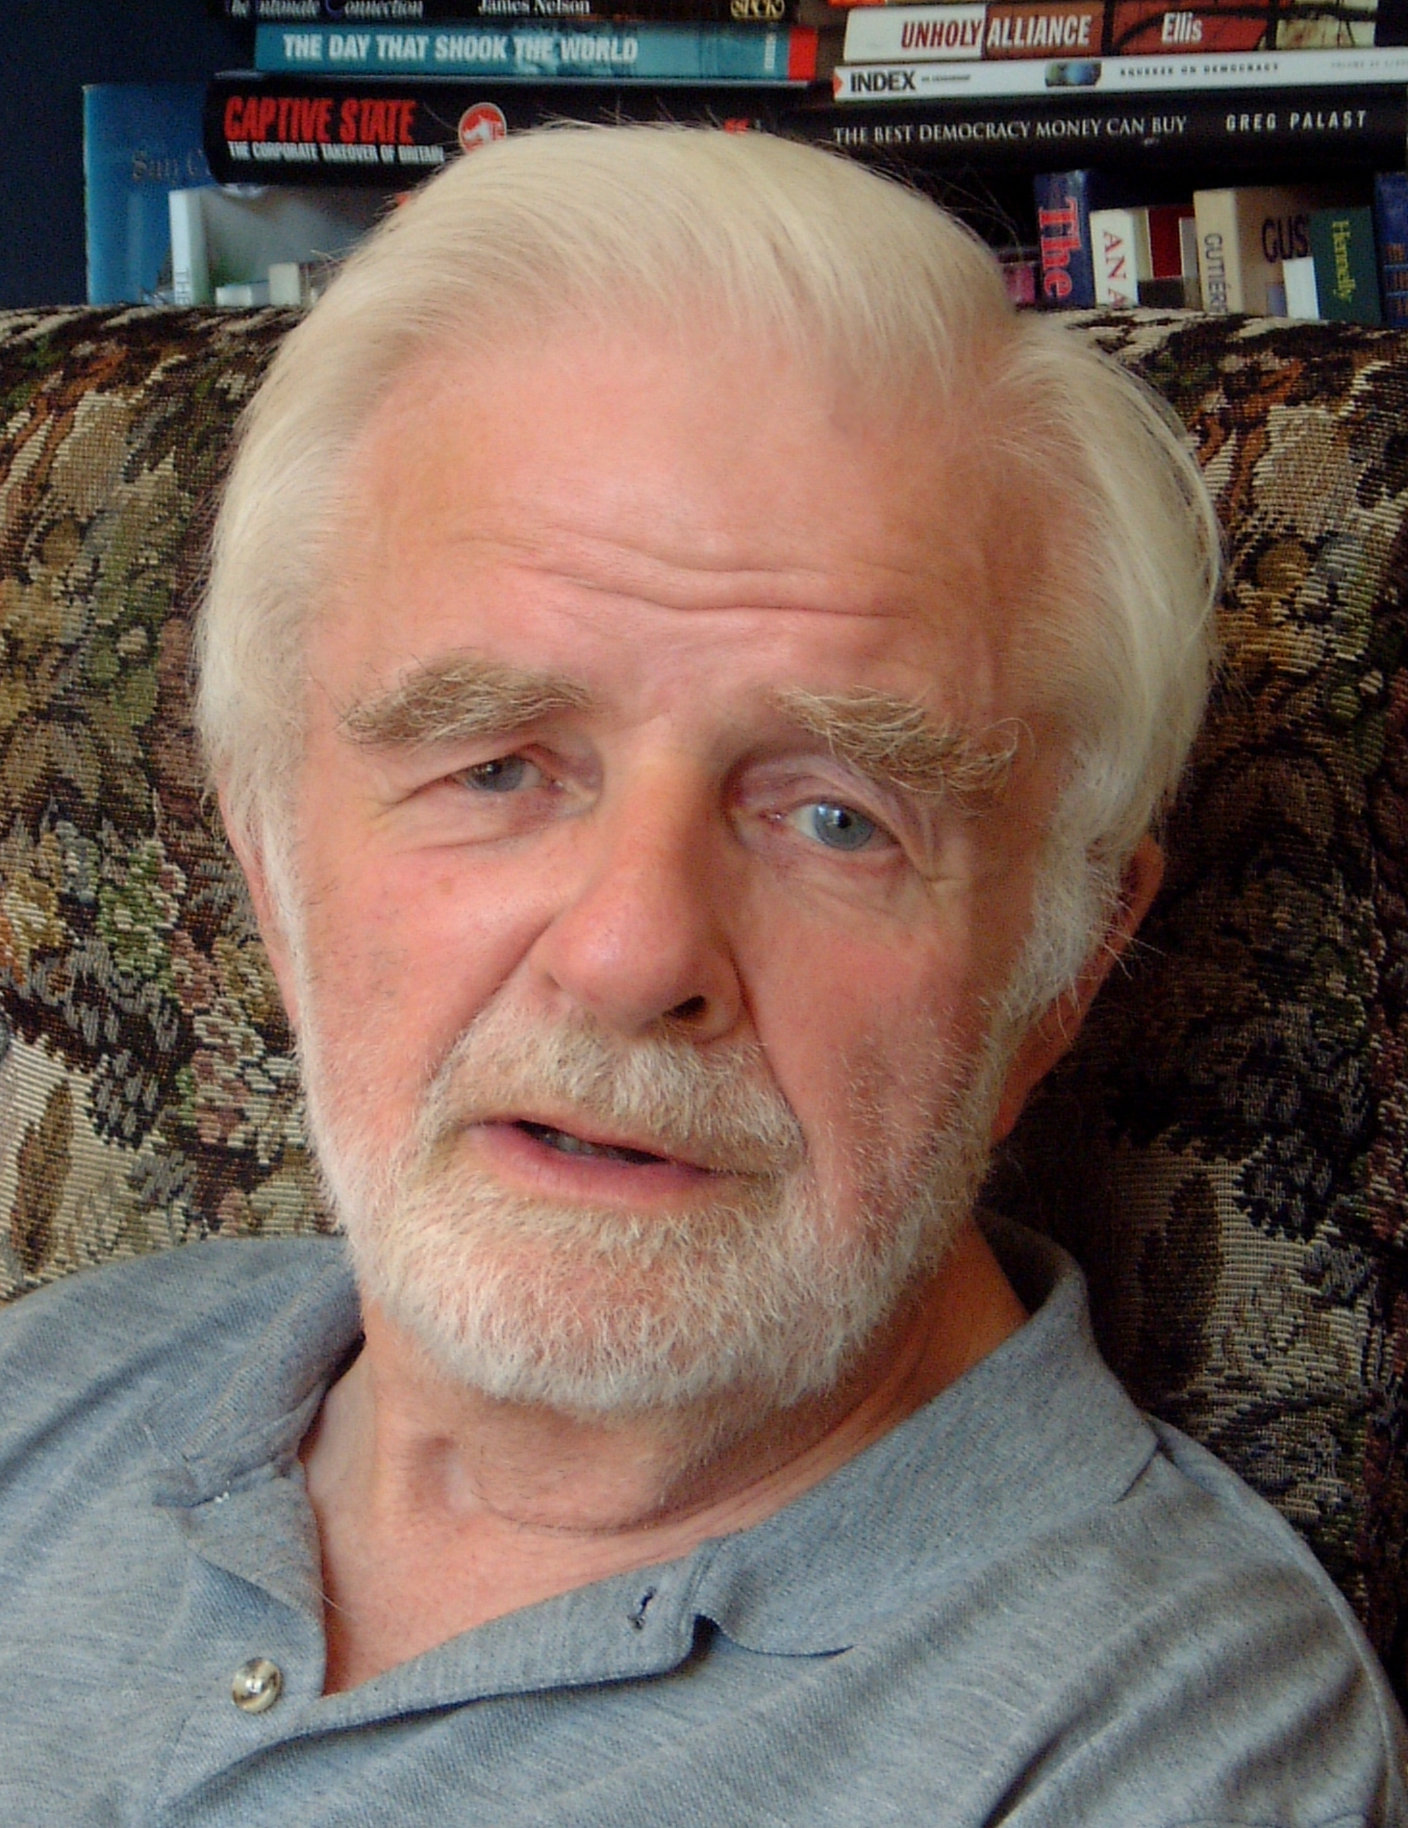  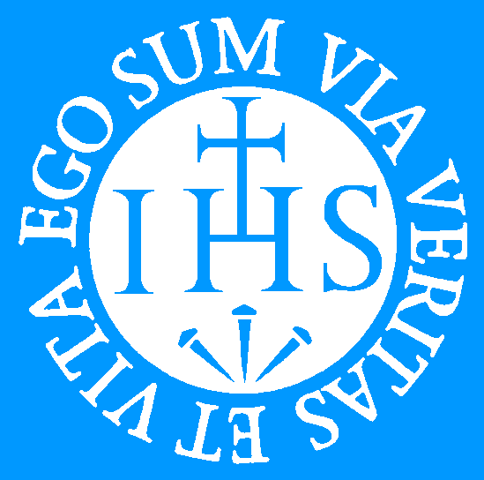 | Imagine  Imagine Patrick Purnell SJ  t r  i  ck  Pu  r  ne  l  l  S J | 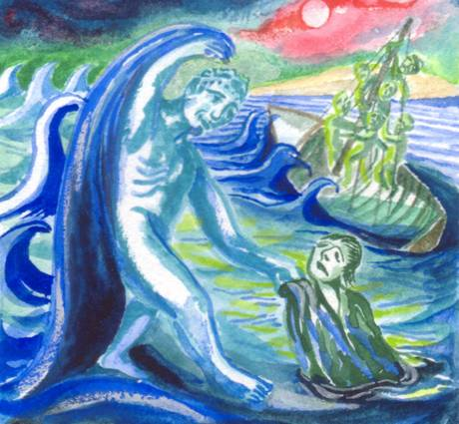  Imagine  Patrick Purnell SJ
  Way Books  Campion Hall Oxford  £7.00 | (barcode)

